**Appendix 3**. We present the results using a ‘cutoff’ of eBird checklists at 50 checklists per city. We do not believe that 50 checklists will necessarily provide ‘adequate community characterization’ in a given city. Previous work (Callaghan et al. 2017; <https://doi.org/10.5751/ACE-01104-120212>) demonstrated birders’ aptitude for finding more-and-more species (i.e., it takes a long time for a species-accumulation curve to plateau because birders are obsessed with finding random individual vagrants etc.). But this work also found that if you are interested at looking at ‘95%’ of the community, then 50 checklists would be sufficient, on average, as it pertains to urban greenspaces. In order to conduct our analysis for cities, we had to choose some lower ‘cutoff’, as it does not make logical sense to use a city with 5 checklists in it (for instance), because the variability in ‘completeness’ as it pertains to that low of a number of checklists in a city would be extremely high. Thus, we used previous work as a rough guide to what might be appropriate and where cities may begin showing some level of completeness in their species accumulation curves. This is why we chose 50 checklists as a minimum. As discussed in the main text, we used ‘weights’ in our models to account for the varying level of underlying sampling effort among the 1,581 cities. This approach works by providing more weight in the regression analysis to those cities (or random patches, depending on the model) that had more underlying eBird checklists. Here we demonstrate what our approach did, and show that even when changing the underlying ‘cutoff’ up to 1500 eBird checklists, the results remain comparable to our key findings presented in the manuscript.

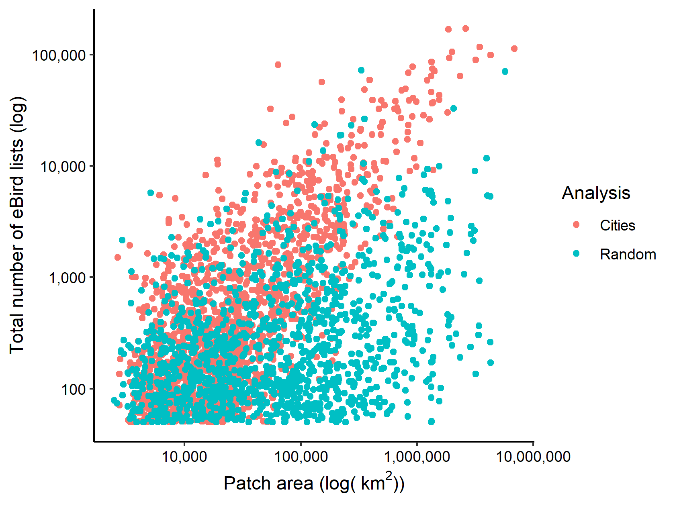

**Figure A1**. The relationship between area of a patch and the number of eBird lists. All data points shown bhere are used in the regression-fitting process, but the fitting procedure works to fit the regression based on the points that have more lists as we believe these points are more ‘trustworthy’ representations of the actual species richness in a patch.

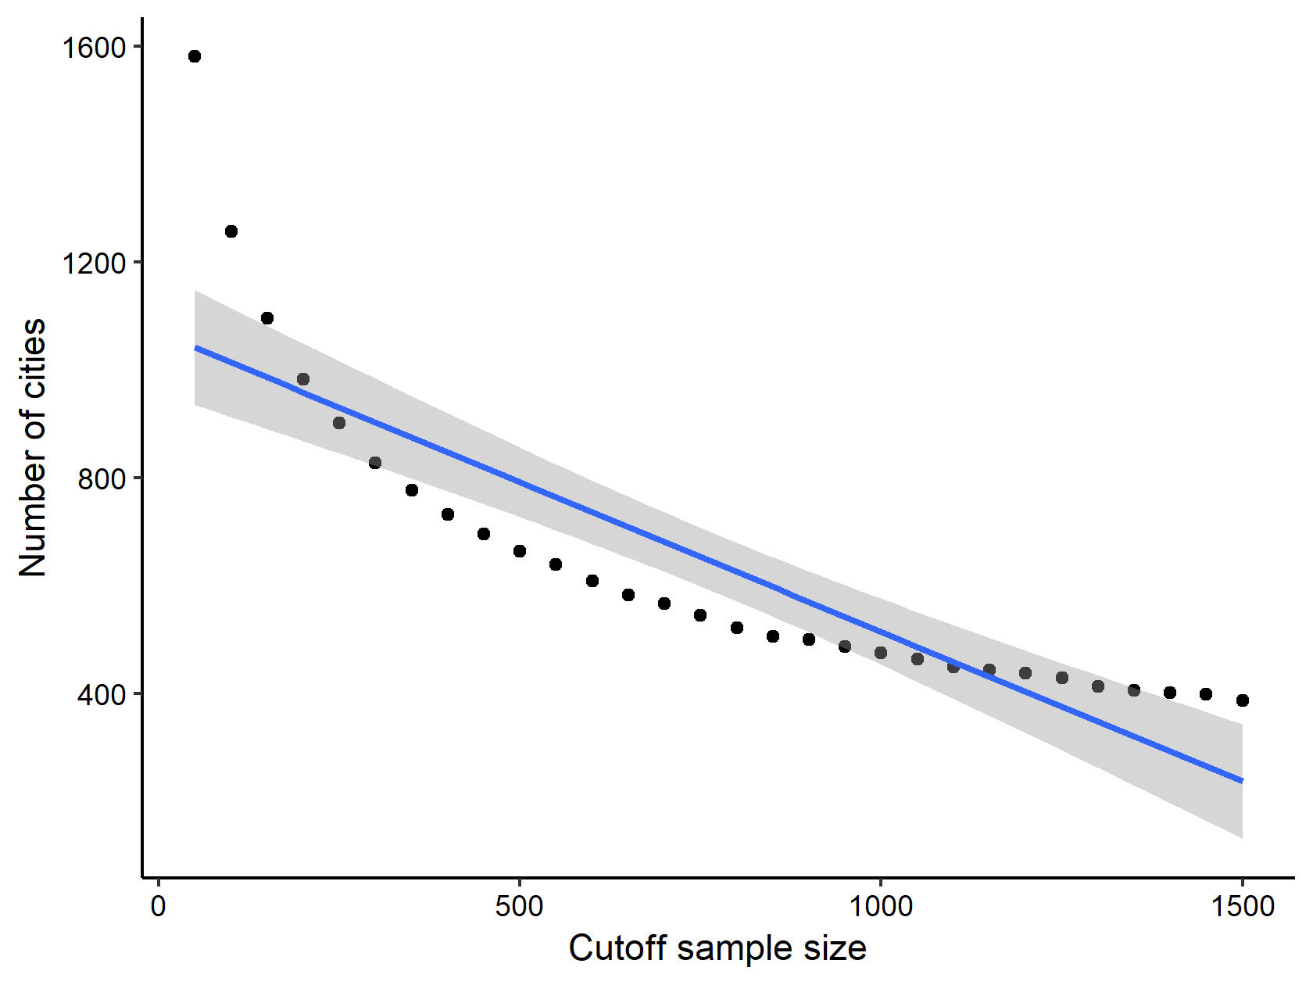

**Figure A2**. We re-assessed our results, using a varying underlying ‘cutoff’ for the number of eBird checklists in a city, increasing it from 50 (our original cutoff) to 1500, by 50. As the cutoff used for minimum number of eBird checklists (x-axis) increases, the number of cities included in the analysis (y-axis) decreases.

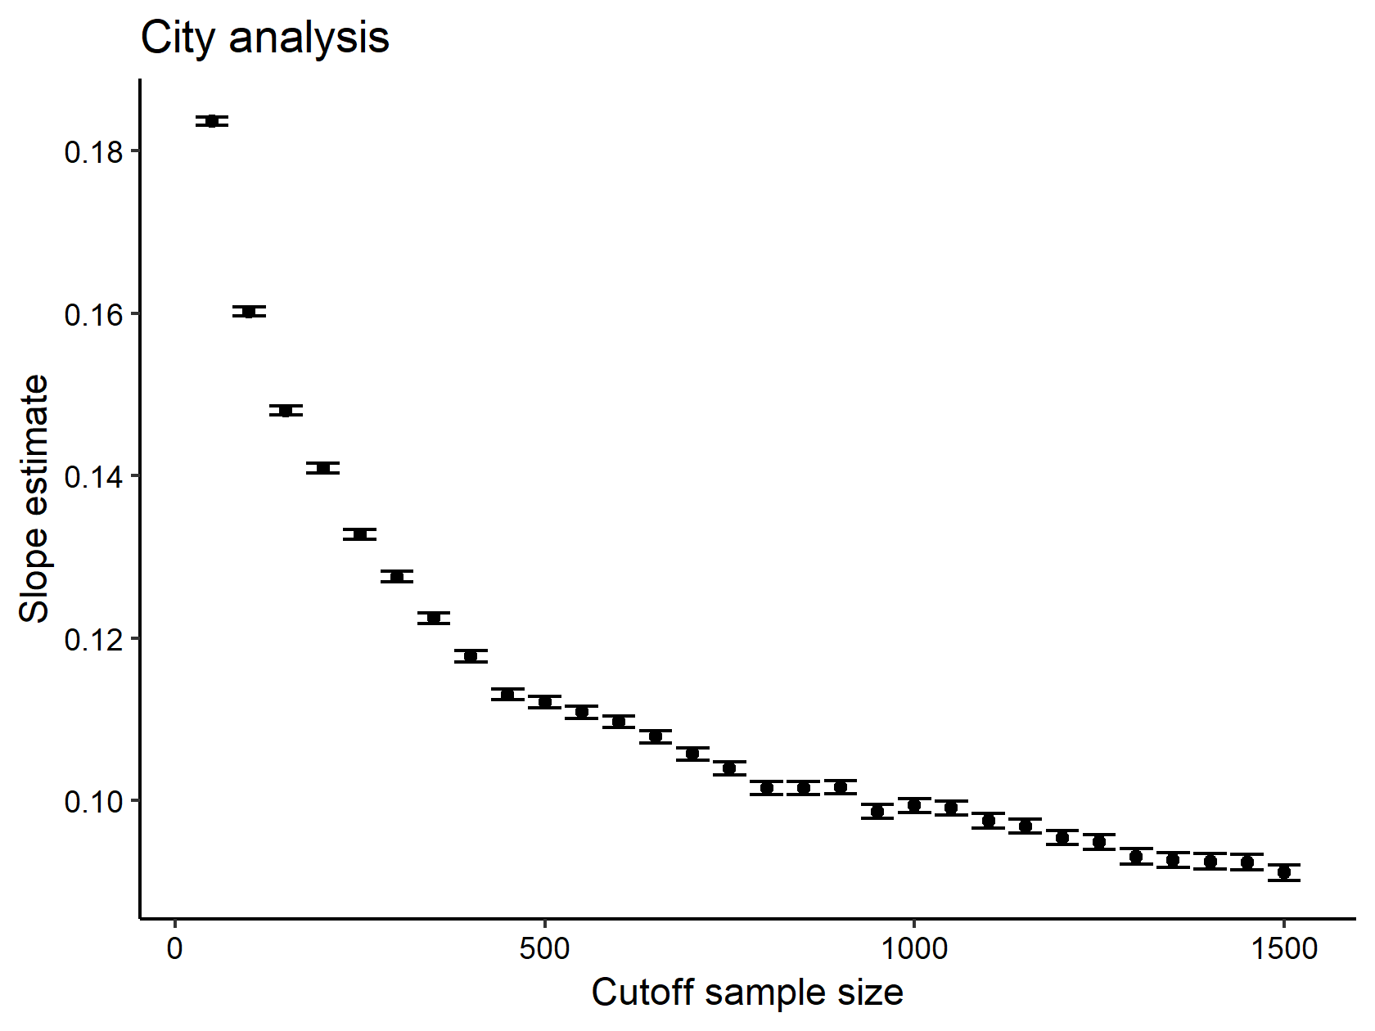

**Figure A3**. The slope of the species-area relationship in cities remained significantly positive (p<0.001), even when including increasingly smaller subsets of cities in the analysis.

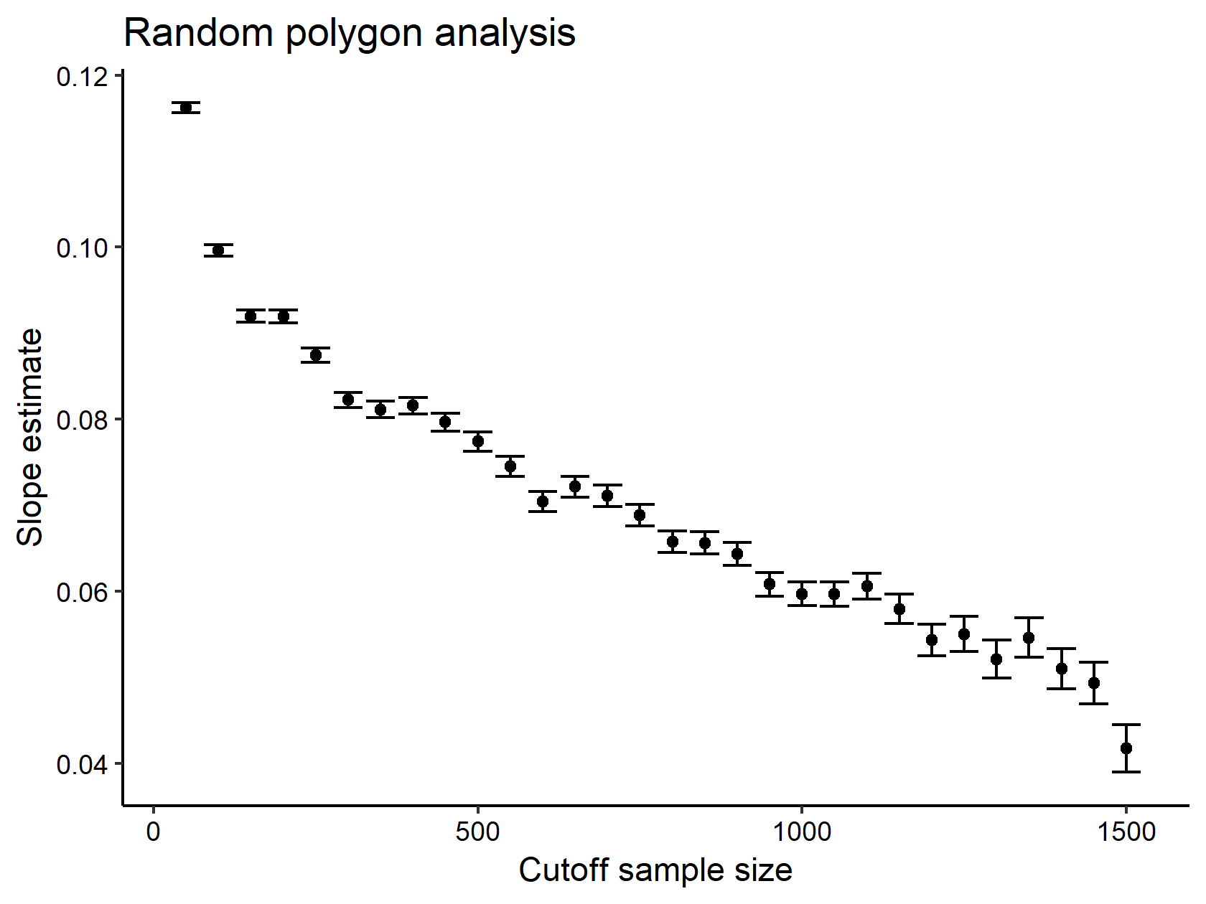

**Figure A4**. As in Figure A3, the slope of the species-area relationship in random polygon patches remained significantly positive (p<0.001), even when including increasingly smaller subsets of cities in the analysis. Importantly, in both instances, as the ‘cutoff’ is increased, then the smaller cities are most likely to be dropped from the analysis as there is a generally positive relationship between area of a city and the number of eBird lists (Figure A1, above). This likely results in the decreasing pattern found in the slope relationship in Figure A3 & Figure A4, as the slope would be greatest when including the full set of potential patches (i.e., more ‘smaller’ patches which creates a more positive slope).

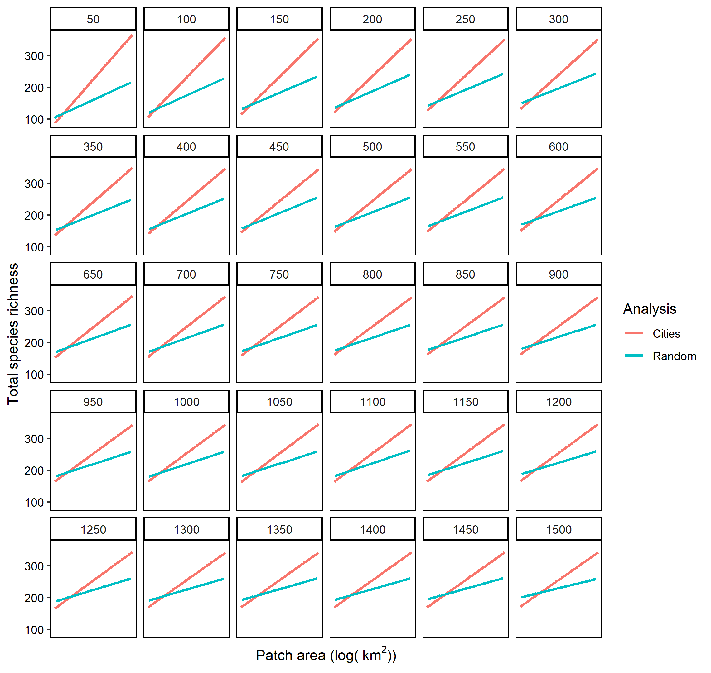

**Figure A5**. Empirical relationship between patch area and the total species richness found in a patch, for cities (red line) and random patches (blue line). The number in each panel is the corresponding cutoff size used for inclusion of a city.

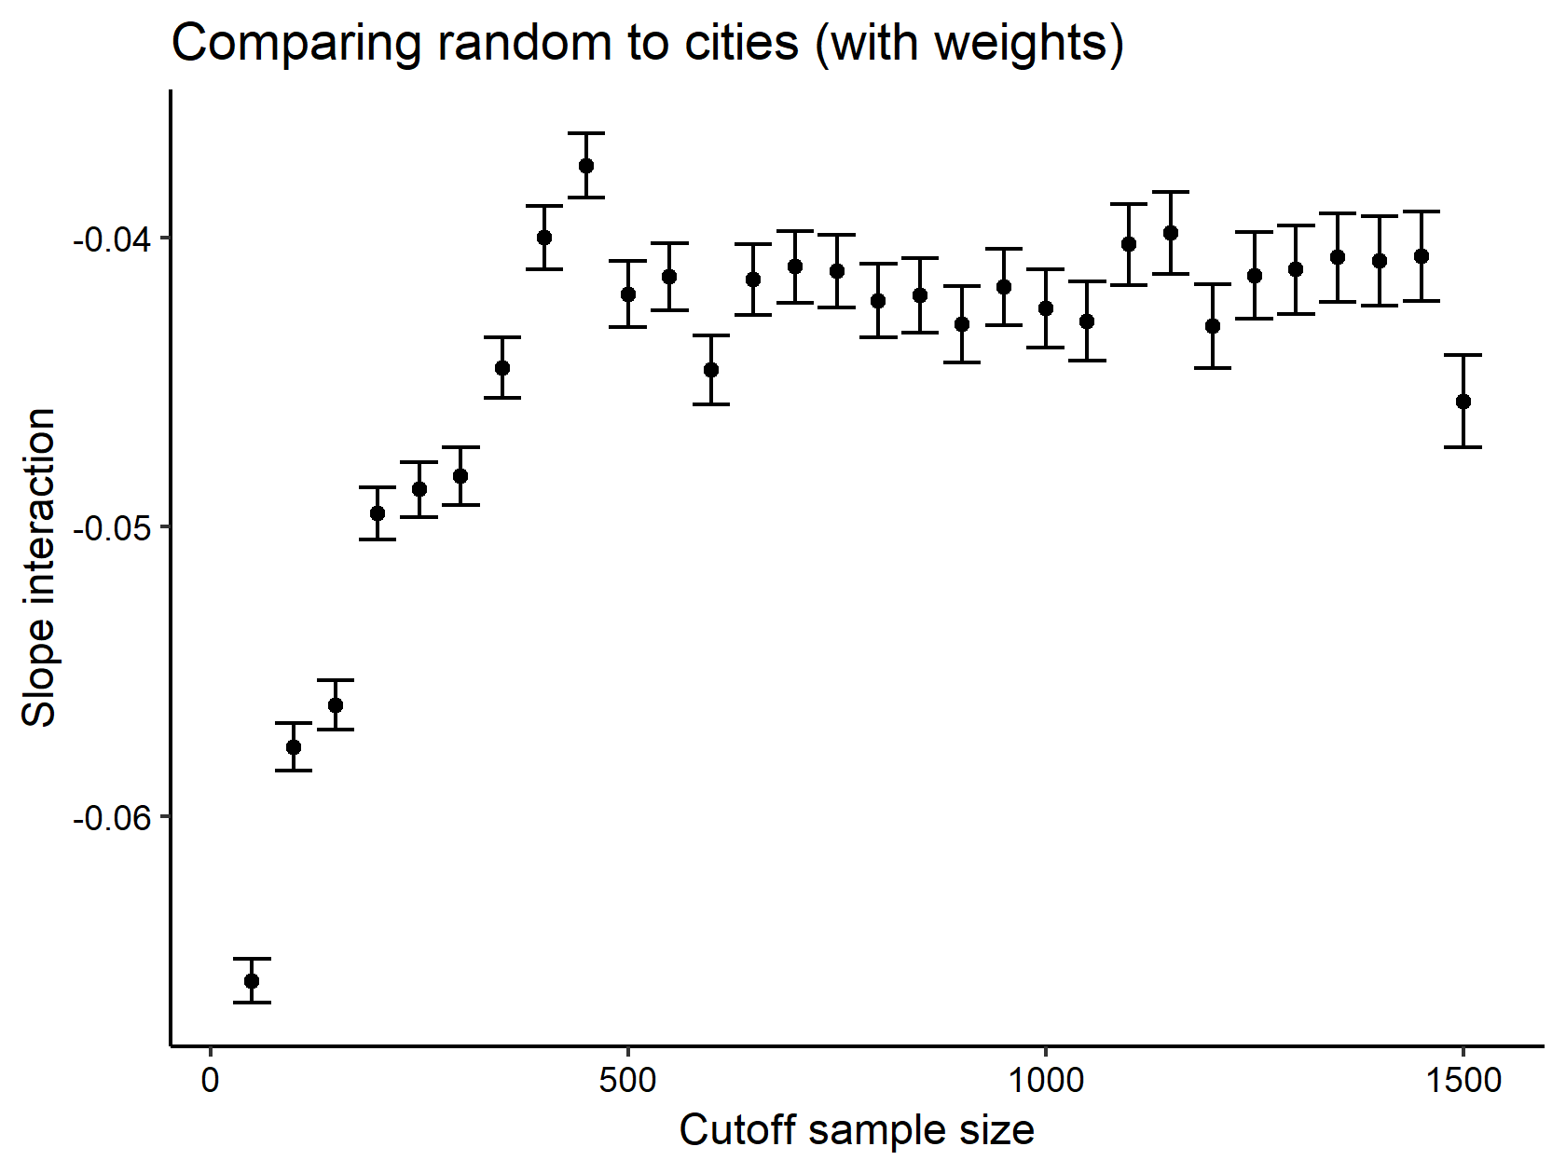

**Figure A6**. The estimate for the slope interaction between ‘analysis’ (random or cities) and the patch area in a fitted GAM, where the GAMs were fitted with weights for the total number of lists in a city (log-transformed). The relationship remained significant (p<0.001) across underlying cutoff sample sizes. However, note again that the difference between the two slopes generally decreases with cutoff size, likely an artefact of ‘removing’ smaller patches from the analysis. This pattern also appears to ‘level-off’ at a certain point suggesting that among larger cities, the pattern becomes increasingly robust.